Rational Decision Making: Create your own model!
There are 7 steps in Rational Decision Making – from Identification to Implementation – this is a typical model of the Rational Decision Making process. Create a sample one in the box below that illustrates a problem you see at school or work that you can find a solution using this model.
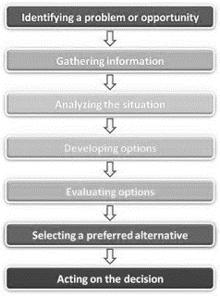
___________________________________________________________________________________________
Now, create a Rational Decision Model that looks like the CLOCK model in the last set of notes. Use the chart below to come up with a model that uses SPECIALIZATION to create a product. You have 5 employees and your product has 4 parts.

Method One _______________________ = cost per product
Method Two _______________________ = cost per product
Create a saving or financial investment plan for a future goal!

My most important PERSONAL five goals are: How do you plan on achieving this goal? Explain.

