ANSWER ON YOUR OWN SHEET OF PAPER!!

Review what we’ve learned for GPS SSEF1:
SSEF1 Explain why limited productive resources and unlimited wants result in scarcity, opportunity costs, and
tradeoffs for individuals, businesses, and governments.
- Define scarcity as a basic condition that exists when unlimited wants exceed limited productive resources (needs)
- Define and give examples of productive resources (factors of production) (e.g., land (natural), labor
(human), capital (capital goods), entrepreneurship).
C. List a variety of strategies for allocating scarce resources.
D. Define opportunity cost as the next best alternative given up when individuals, businesses, and
governments confront scarcity by making choices.
___________________________________________________________________________________________

Define:
- Scarcity
- Wants
- Needs
- Factors of production
- Allocating (allocation)
- Opportunity cost
___________________________________________________________________________________________

Answer:
- Zhu Zhu pets are a popular gift for the holiday season. Adults will scramble to buy these for children. But, there will not be enough available for everyone. This is an example of
  - Scarcity
  - Loss
  - Profit
  - Loss
- The basic economic problem of all economies is essentially one of deciding how to make the best use of
  - Unlimited resources to satisfy unlimited wants
  - Limited resources to satisfy unlimited wants
  - Unlimited resources to satisfy limited wants
  - Limited resources to satisfy limited wants
- An example of a non-scarce good is
  - Shark Meat
  - Air
  - Chicken Meat
  - Gadgets
- Goods or services that are necessary for living such as food, clothing and shelter are
  - Needs
  - Wants
  - Advertising
  - Factory
- When there is not enough goods and services to meet people’s needs is
  - Scarcity
  - Adversity
  - Disbursement
  - Opportunity Cost
- All of the following are examples of opportunity cost except:
A. the leisure time sacrificed to study for an exam.
B. the tuition fees paid to a university.
C. the income which could have been earned by a college student had he or she worked full time
instead of attending college.
- the building which could have been built with the construction materials and labor used to build a
new university library.
- Which of the following is the best definition of opportunity costs?
- The amount of one good that must be given up in order to produce one more unit of another good.
- The amount of money that must be paid in order to purchase one more unit of a good
- The amount of an input that must be used in order to produce one more unit of a good
- The price of a good that must be charged in order for a merchant to sell one more unit.
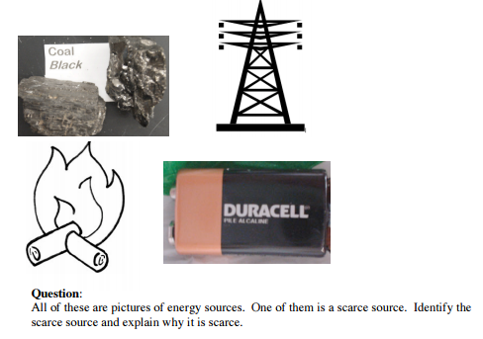

________________________________________________________________________________________

Identify the appropriate factor:
- ___________________________ Your purse that is made from leather
- ___________________________ The oil that you put in your car
- ___________________________ The president of Columbus State University
- ___________________________ The owner of The Posh Peach, a cute dress store downtown.
- ___________________________ The pencil sharpener in a classroom
- ___________________________ A policeman’s car
- ___________________________ The owner of the Goo-Goo Carwashes
- ___________________________ The popcorn at Carmike Theatre
- ___________________________ The clothes at Aeropostle
- ___________________________ the gold in your necklace
- ___________________________ the jewelry in a jewelry store
- ___________________________ the box your Little Caesar pizza comes in
- ___________________________ Pine Trees
Using your notes and what you’ve learned for Allocation – fit the scenario to the best allocation method.
- ___________________________ Beyonce is performing at the Georgia Dome on September 26th. Ticket prices range from $45 to $2,401. There are only 300 tickets left. What is the best way to distribute these tickets?
- ___________________________ Would you like to win a million bucks? What is the best method to win this amount?
- ___________________________ Drake is coming to Columbus! Only Kendrick High School students are allowed to attend. What is this allocation method?
- ___________________________ a certain student cuts in the lunch line to get to the front every day.
- ___________________________ Your dad expects you to help him in the business, like he did his father.
___________________________________________________________________________________________
- What is the fundamental economic problem?
- What is the difference between a want and a need?
- How does scarcity affect the production of goods and services?
- How do the four factors of production affect products you use every day?
- What are the three types of money?
- What is bartering?
- What are the functions of money?
- What is economics?
- What are the three basic economic questions?
- What are the four factors of production?
- What is opportunity cost?
- If you had an exam today what would you make as a grade?
- How much does the GMA count towards your grade in this class?

